Why Jenkins?

Jenkins is a software that allows **continuous integration**. Jenkins will be installed on a server where the central build will take place. The following flowchart demonstrates a very simple workflow of how Jenkins works.

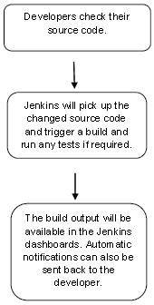

Along with Jenkins, sometimes, one might also see the association of **Hudson**. Hudson is a very popular open-source Java-based continuous integration tool developed by Sun Microsystems which was later acquired by Oracle. After the acquisition of Sun by Oracle, a fork was created from the Hudson source code, which brought about the introduction of Jenkins.

What is Continuous Integration?

Continuous Integration is a development practice that requires developers to integrate code into a shared repository at regular intervals. This concept was meant to remove the problem of finding later occurrence of issues in the build lifecycle. Continuous integration requires the developers to have frequent builds. The common practice is that whenever a code commit occurs, a build should be triggered.

System Requirements

|  |  |
| --- | --- |
| JDK | JDK 1.5 or above |
| Memory | 2 GB RAM (recommended) |
| Disk Space | No minimum requirement. Note that since all builds will be stored on the Jenkins machines, it has to be ensured that sufficient disk space is available for build storage. |
| Operating System Version | Jenkins can be installed on Windows, Ubuntu/Debian, Red Hat/Fedora/CentOS, Mac OS X, openSUSE, FReeBSD, OpenBSD, Gentoo. |
| Java Container | The WAR file can be run in any container that supports Servlet 2.4/JSP 2.0 or later.(An example is Tomcat 5). |

Download Jenkins

The official website for Jenkins is [Jenkins](https://jenkins-ci.org/). If you click the given link, you can get the home page of the Jenkins official website as shown below.

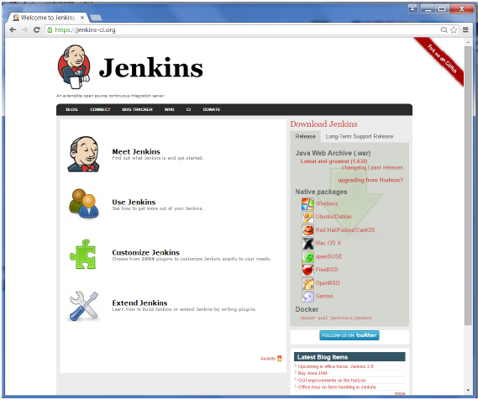

By default, the latest release and the Long-Term support release will be available for download. The past releases are also available for download. Click the Long-Term Support Release tab in the download section.

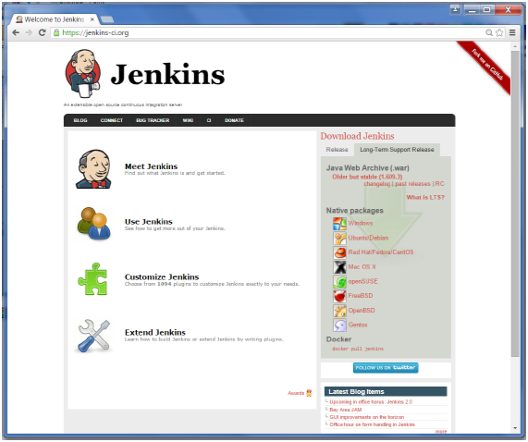

Click the link “Older but stable version” to download the Jenkins war file.

Starting Jenkins

Open the command prompt. From the command prompt, browse to the directory where the jenkins.war file is present. Run the following command

D:\>Java –jar Jenkins.war

After the command is run, various tasks will run, one of which is the extraction of the war file which is done by an embedded webserver called winstone.

D:\>Java –jar Jenkins.war

Running from: D:\jenkins.war

Webroot: $user.home/ .jenkins

Sep 29, 2015 4:10:46 PM winstone.Logger logInternal

INFO: Beginning extraction from war file

Once the processing is complete without major errors, the following line will come in the output of the command prompt.

INFO: Jenkins is fully up and running

Accessing Jenkins

Once Jenkins is up and running, one can access Jenkins from the link − **http://localhost:8080**

This link will bring up the Jenkins dashboard.

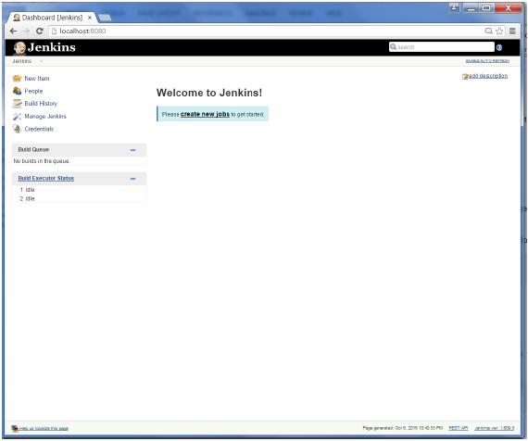

The following prerequisites must be met for Jenkins Tomcat setup.

Step 1: Verifying Java Installation

To verify Java installation, open the console and execute the following java command.

|  |  |  |
| --- | --- | --- |
| **OS** | **Task** | **Command** |
| Windows | Open command console | \>java –version |
| Linux | Open command terminal | $java –version |

If Java has been installed properly on your system, then you should get one of the following outputs, depending on the platform you are working on.

|  |  |
| --- | --- |
| **OS** | **Output** |
| Windows | Java version "1.7.0_60"  Java (TM) SE Run Time Environment (build 1.7.0_60-b19)  Java Hotspot (TM) 64-bit Server VM (build 24.60-b09, mixed mode) |
| Linux | java version "1.7.0_25"  Open JDK Runtime Environment (rhel-2.3.10.4.el6_4-x86_64)  Open JDK 64-Bit Server VM (build 23.7-b01, mixed mode) |

We assume the readers of this tutorial have Java 1.7.0_60 installed on their system before proceeding for this tutorial.

In case you do not have Java JDK, you can download it from the link [Oracle](http://www.oracle.com/technetwork/java/javase/downloads/jdk7-downloads-1880260.html)

Step 2: Verifying Java Installation

Set the JAVA_HOME environment variable to point to the base directory location where Java is installed on your machine. For example,

|  |  |
| --- | --- |
| **OS** | **Output** |
| Windows | Set Environmental variable JAVA_HOME to C:\ProgramFiles\java\jdk1.7.0_60 |
| Linux | export JAVA_HOME=/usr/local/java-current |

Append the full path of the Java compiler location to the System Path.

|  |  |
| --- | --- |
| **OS** | **Output** |
| Windows | Append the String; C:\Program Files\Java\jdk1.7.0_60\bin to the end of the system variable PATH. |
| Linux | export PATH=$PATH:$JAVA_HOME/bin/ |

Verify the command java-version from command prompt as explained above.

Step 3: Download Tomcat

The official website for tomcat is [Tomcat](http://tomcat.apache.org/). If you click the given link, you can get the home page of the tomcat official website as shown below.

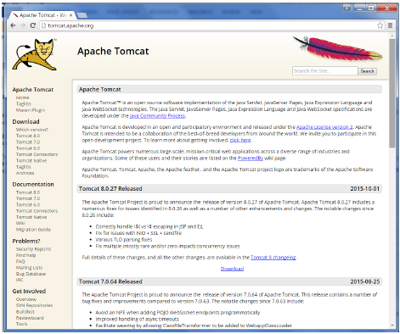

Browse to the link <https://tomcat.apache.org/download-70.cgi> to get the download for tomcat.

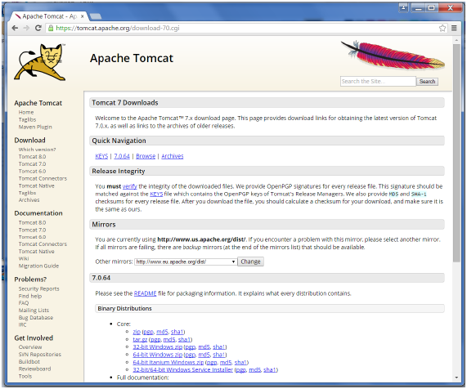

Go to the ‘Binary Distributions’ section. Download the 32-bit Windows zip file.

Then unzip the contents of the downloaded zip file.

Step 4: Jenkins and Tomcat Setup

Copy the Jenkis.war file which was downloaded from the previous section and copy it to the webapps folder in the tomcat folder.

Now open the command prompt. From the command prompt, browse to the directory where the tomcat7 folder is location. Browse to the bin directory in this folder and run the start.bat file

E:\Apps\tomcat7\bin>startup.bat

Once the processing is complete without major errors, the following line will come in the output of the command prompt.

INFO: Server startup in 1302 ms

Open the browser and go to the link − **http://localhost:8080/jenkins**. Jenkins will be up and running on tomcat.

